(PART - B)

Roll.No. : A073 | Name: Aryan Srivastava
Sem/Year : MCA FY | Batch: B3
Date of Experiment : 20 aug | Date of Submission: 20 aug
Grade --

B.1: Procedure of performed experiment
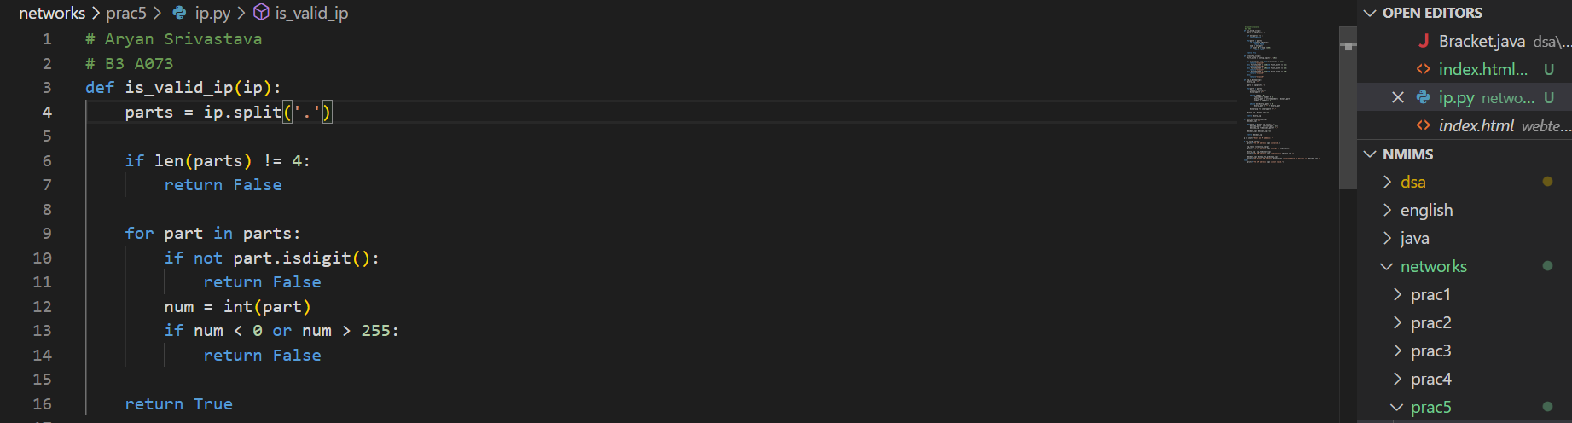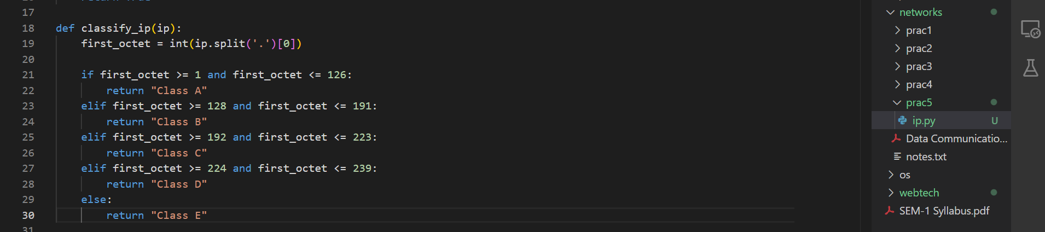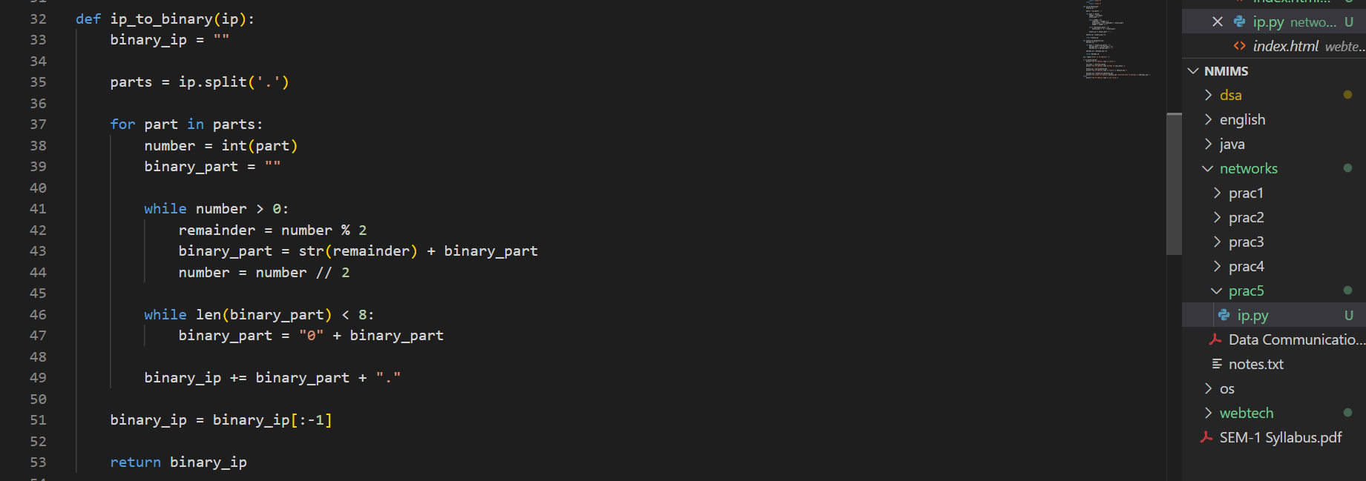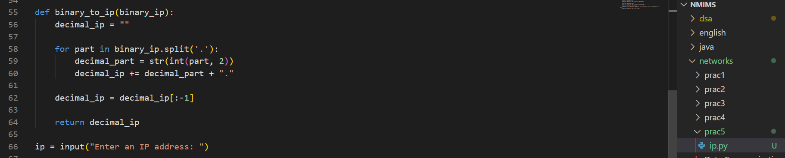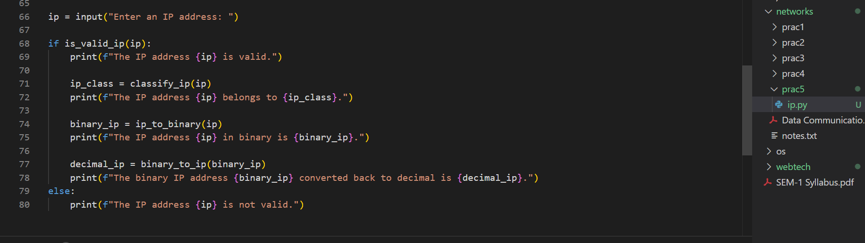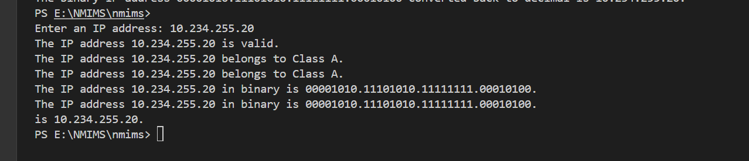

B.2: Observations and Learning’s:
Validation: The IP address must have four octets, each between 0 and 255, to be considered valid.
Classification: IP addresses are classified into classes A, B, C, and D based on the value of the first octet.
Conversion: Converting IP addresses between dotted decimal and binary formats helps in understanding the internal representation of IPs and subnetting.

B.3: Conclusion:
The experiment helped in understanding IP address structure, validation, classification, and conversion between decimal and binary formats. It demonstrated the importance of accurate IP address handling in networking.

B4: Questions of Curiosity
- Identify the reasons for adoption of IPV6 address format.
IPv6 Adoption: IPv6 is adopted due to the exhaustion of IPv4 addresses. It provides a larger address space (128-bit vs. 32-bit), improved routing, and built-in security features.
- What is routable IP address and non-routable IP address? Give examples of each.
Routable IP Address: Can be routed on the internet (e.g., 8.8.8.8).
Non-Routable IP Address: Used within local networks and not routable on the internet (e.g., 192.168.1.1).
- What is Loopback IP? What is the significance of Loop
The IP 127.0.0.1 is used to test network functions locally on the same machine. It helps in verifying the network stack without external network access.

